DESIGN THINKING FOR SOFTWARE ENGINEERING
LAB – 02

Scenario: CONSUMERS FACE MISLEADING ADVERTISEMENTS ONLINE

Context
Consumers frequently encounter misleading advertisements on digital platforms such as:
- Social media (Instagram, YouTube, Facebook)
- E-commerce websites
- Influencer promotions
- Sponsored search results
- Mobile apps and websites
User :-
Example:
- Age: 18–45 years
- Education: School / College / Working Professional
- Device: Smartphone / Laptop
- Digital Literacy: Medium to High
- Platforms Used: Social media, shopping apps, search engines

Assumptions :-

ID | Assumption
A1 | Consumers trust online advertisements easily.
A2 | Most users do not read terms and conditions.
A3 | Attractive advertisements make users click impulsively.
A4 | Users get misled by ads on social media platforms like Instagram, Telegram, and YouTube.

Interview Questions :-
- How would you describe your experience after purchasing a product that did not match its online advertisement?
- What do you usually tell others when you feel an online advertisement was misleading?
- How do you express your dissatisfaction when an online product fails to meet advertised claims?
- What goes through your mind when you realize the advertisement exaggerated the product features?
- How do you decide whether to trust an online advertisement before making a purchase?
- What conclusions do you form about a brand after facing misleading promotions?
- What actions do you take immediately after discovering that an online advertisement was misleading?
- How do you change your buying behaviour after such an experience?
- What steps do you take to avoid being misled by similar advertisements in the future?
- How do you feel when the actual product does not match what was promised online?
- What emotions do you experience during the process of dealing with misleading advertisements?
- How does repeated exposure to misleading online advertisements affect your trust in online shopping?

User Interview :-

Hesitation:
- User hesitated before trusting the online advertisement
- Took time to decide due to exaggerated claims

Facial Expressions:
- Looked confused while explaining the difference between the ad and the product
- Showed frustration when talking about the loss of money

Repeated Questions:
- “Is this advertisement genuine?”
- “Why does the product look different from the ad?”
- “Can online ads really be trusted?”

Exact Statements:
- “The product shown in the advertisement was completely different.”
- “I feel online ads promise more than what they deliver.”
- “I lost trust after being misled once.”
- “Now I think twice before clicking on any advertisement.”

“Misleading ads cause confusion and frustration, leading to loss of trust and cautious online buying.”

Empathy Mapping :-
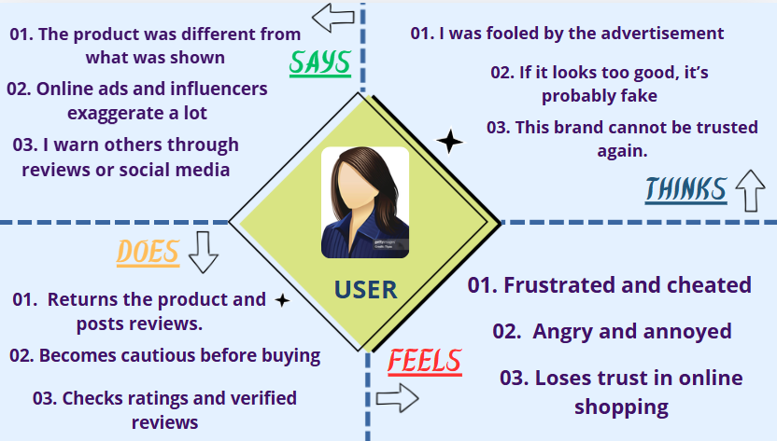

Validate Assumptions :-

Assumption | Validated? | Reason
Consumers trust online ads | ❎ | User said trust is reduced
Users don’t read details | ❎ | User checks material quality
Attractive ads influence clicks | ✅ | User uses Instagram ads
Social media ads mislead users | ✅ | User faced mismatch issues

User Insights :-
- Consumers rely more on reviews than advertisements
- Mismatch between image and product breaks trust
- Repeated bad experiences lead to long-term distrust
- Honesty matters more than visual appeal

❎ “Consumers buy blindly”
✅ “Consumers buy cautiously after experiencing misleading ads”

User Persona :-
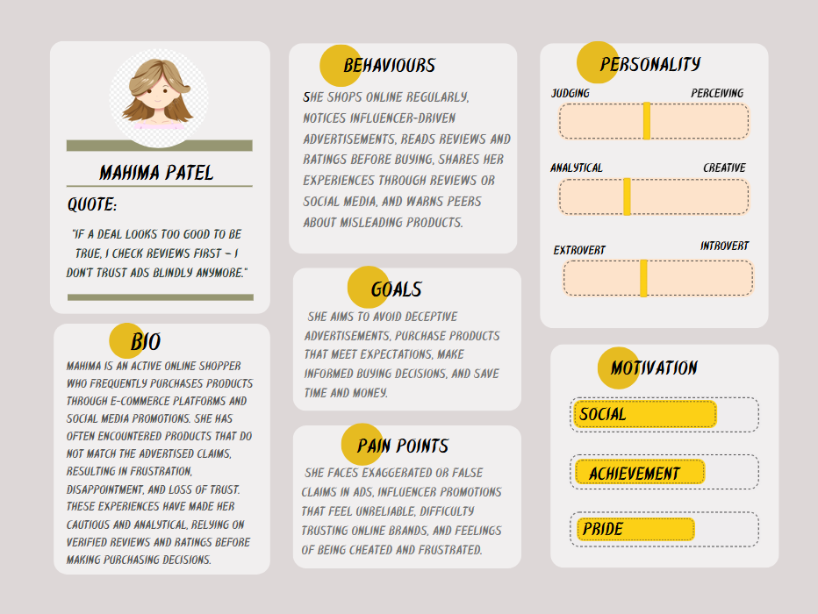

Insights to Software Needs :-

Insight | Software Requirement
Image–product mismatch | Real product images
Fake hype | Verified customer reviews
Trust issues | Seller authenticity checks
User frustration | Easy return & refund
Misleading ads | Strict ad guidelines

Reflection & Documentation :-
- What surprised you during the interview?
→ The user trusts reviews more than advertisements.
- Which assumption was wrong?
→ The assumption that users don’t read product details.
- How did empathy change your thinking?
→ It helped understand how misleading ads emotionally affect consumers.1
- How will this affect your software design approach?
→ Focus on transparency, honesty, and verified information.

